| |
Condorcet  Tally  C.T. is a Key to  Pick a Popular Policy  for Schools, Clubs, Towns & More |  | A Less Rigged Agenda Now!  Some meetings concoct a policy by a series of yes-no choices, with or without rules of order, agendas or votes. An early proposal might have to beat each later one. An early decision might preclude some later proposals. So “stacking the agenda” can help or hurt proposals.  Other meetings discuss the rival options all at once. But often, many members express no backup choices. So similar options split supporters and hurt each other. Then a minority pushing one option can appear to be the strongest group. Even sadder, a member with a well-balanced option but few eager supporters might drop it.  Too often, a committee chooses all the parts in a bill. Other members can say only yes or no to that bundle.  Rigged votes often build bad policy and animosity. To reduce these risks, let the voters rank more options.¹  Ballot On Issue A  Rank Option  3 Continue Discussion  2 Original Bill, the main motion  1 Bill with Amendment 1 (a free rider?)  8 Bill with Amend. 2 (a wrecking amend.?)  7 Bill with Amendments 1 and 2  4 Postpone for 7 days  5 Refer the Bill to a Committee  6 No Change (a vote for gridlock exposed?)  The “Incidental Motions” do not wait for the ballot,  e.g. a personal complaint or request. 33 |  | 4. Condorcet Tally Centers a Policy  In a Condorcet tally, the winner must top all rivals,  one-against-one. Two games show how it works.  1) Flag L stands at our center, by the median voter. Flags J, K and M surround L, 2 m. or yards from it.  We asked 9 voters: “Are you closer to J than to K? If so, please raise a hand.” Only one raised a hand.  We entered J vs. K, etc. in the pairwise table below.  against J K L M  for J — 1 3 4  for K 8 8+1=9 4 5  for L 6 5 — 5  for M 5 4 4 4+5=9  The nine voters gave L a majority over each rival.  2) Flag L has a short Red ribbon and a long Blue one.  If the Red ribbon gets to you, the Red policy gets your vote with its narrow appeal.  But if the Red cannot touch you, the wide appeal of the Blue policy gets your vote. Which one wins?  If the flags are places for a heater in an icy cold room:  1. Do we put it at our center or in the biggest group?  2. Do we turn on its fan to spread the heat wide?  3. Do voters on the fringes have any influence?  4. Can the median voter enact any policy alone?  5. Do we get a balanced or a one-sided policy?  Usually: Blue. Center. Yes. Yes. No. Balanced. 45

| Here are more pages from the free eBook.* |
The goal in a Condorcet Tally is this:  Majority victories,  over every single rival.  The winner must top every rival, one-against-one.  The sports analogy is a “round-robin tournament.” A player has one contest with each rival. If she  wins all her tests, she wins the tournament.  Each voting test sorts all the ballots into two piles. If you rank option K above L, your ballot goes to K. The option that gets the most ballots wins this test. If one wins all its tests, it wins the Condorcet Tally. In a rare, “voting cycle,” majorities rank K over L,  L > M, and M > K. RCV can break the tie.*  K L  M  Why Use a Condorcet Tally, CT  Choice ballots: rank the related options on one ballot. Simplify the old rules of order and speed up voting. Reduce agenda effects, from simple errors and gridlock, to “free-rider” and “wrecking” amendments.  A balanced policy tends to be stable, thus decisive. Yet, a balanced process can calm some fears about reviewing and changing a good policy to improve it. This saves time and builds respect for democracy.  No split-vote worries as duplicates don't help or hurt  each other. An ad hoc majority can rank all of their  favorites over the other options. Ballots from all voters  help decide which of the majority’s favorites wins.  * The first handout was about Hare’s RCV rule. 30 | Achieve Policies with Wider Appeal  A plurality or runoff winner gets no votes from the  losing side and doesn't need to please those voters.  But each CT option needs support from all sides,  because every voter can rank it against its close rivals. Thus every voter is “obtainable” and valuable.  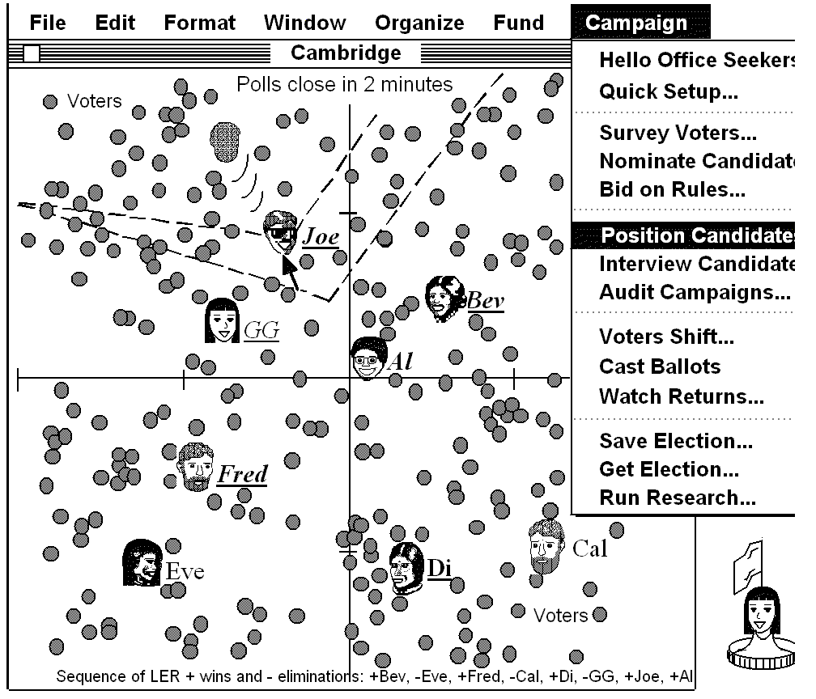  So the winner is well balanced and widely popular.^{2, 3} Voters on the center and right give it a majority over any left-wing policy. At the same time, voters on the  left and center like it more than any right-wing policy.  All sides like it more than a narrowly-centrist policy.  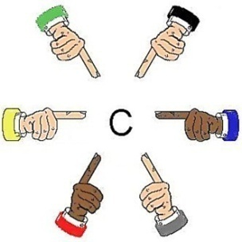  “Our center  is near me.”  “I think it's  right here.”  “I am the  center!"  Everyone helps locate our center.  A Chair with Balanced Support  CT can elect a chairperson or a few reps to be the swing voters in an Ensemble Council, as pictured on pages 8 and 54. To win, a candidate needs to earn wide support. This gives her strong incentives to help the council balance its process and policies.  RCV has slightly different effects, incentives and uses.²  Games will put us inside each tally to feel how it works.  © 2023, Robert Loring, VotingSite@gmail.com  Free  AccurateDemocracy.com/AcDem.pdf | 4. Watch Condorcet Find the Center  This map puts a line halfway between Al and a rival. Voters on Al’s side of a line are closer to her and so rank her higher than the rival. The long line has more voters on Al’s side than on Joe’s. So Al wins that test. Al wins a very different majority over each rival here. To do that, Al's political positions must be central and have widespread support.  In contrast, PRCV requires the most intense support, first-rank votes, to avoid early elimination. Seepage 48  RCV does too, with a high finish line of 50% + one vote.  © 1996, from PoliticalSim™ by Robert Loring 56

