| | |
Electing Reps  2. The principle of Fair Representation is:  Get true majority rule by representing  each group in proportion to its voters.  That is, 60% of the vote gets you 60% of the seats,  not all of them. And 20% of the vote gets you 20% of  the seats, not none of them. These are fair shares.  How does it work? There are three basic ingredients:   We elect more than one rep from an electoral district.  You vote for more than one; you vote for a list.  You pick a group's list, or you list your favorites.  The more votes a list gets, the more reps it elects.  Why Support Fair Representation (Fair Rep)  Fair shares of reps go to the rival groups so Diverse candidates have real chances to win so Voters have real choices and effective votes so  Voter turnout is strong.¹  Women win two or three times more often¹ so Accurate majorities win—also due to more: choices, turnout, effective votes, and equal votes per rep so  Policies match public opinion better.²  Many people call this Proportional Representation or PR.  >>>>> OVER  16 |  | Fair Shares and Moderates  Chicago elects no Republicans to the State Congress, even though they win up to a third of the city's votes. But for over a century it elected reps from both parties. The state used a fair rule to elect 3 reps in each district. Most gave the majority party 2 reps and the minority 1. So no district was unwinnable and neglected by 1 party, a captive audience for the other party.  Those Chicago Republicans were usually moderate. So were Democratic reps from Republican strongholds. Even the biggest party in a district tended to elect more independent-minded reps.. They could work together for moderate policies.³    Shares of votes equal fair shares of seats.  New Zealand switched in 1996 from Single-Member Districts to a layer of SMDs within Fair Representation. This is called Mixed-Member Proportional or MMP. A small, one-seat district focuses more on local issues. Fair Rep frees us to elect reps with widespread appeals.  The seats won by women rose from 21% to 29%. The native Maori reps increased from 7% to 16%, which is almost proportional to the Maori population. Voters also elected 3 Polynesian reps and 1 Asian rep.⁴  17 |  | Why Full Rep Elects More Women  New Zealand and Germany elect half of their MPs in Single-Member Districts and half from Fair Rep lists. This is likely the best way to elect a parliament.⁵ The SMDs elect few women; but in the same election, the Fair Rep lists elect two or three times more women.¹  A safe nominee for a two-party duel in an SMD is from the dominant gender, race, religion, etc. It leads to a macho duel and poor representation of all others.  Fair Rep leads a party to nominate a balanced team of candidates to attract voters. This promotes women.⁶ A team can have class, ethnic, and cultural diversity. And that gives us diverse reps to approach for help.  MORE: Real choices, Competition, Effective votes, Voter turnout, Strong mandates, Diverse reps, Women reps, Popular policies  Some leading women spoke of starting a new party in Sweden, which uses Fair Rep. Under plurality rule, a big new party splits its own side, so it likely loses. But Fair Rep gives every big party its share of seats.  This credible threat made an old party decide job experience was not as important as gender balance.  So it dropped some experienced men to raise women higher on the party’s list. And they won.⁷ Now they are incumbents with experience, power and allies.  18
| More pages in the free eBook. |
Voting Rules and Policy Results  Local SMDs can elect reps with unequal vote totals. So a majority of reps might not represent most voters. Fair Representation has more equal votes for each rep. So each majority of reps does stand for most voters.  This produces policies closer to public opinion.²  LESS: Wasted votes,  Gerrymandered districts,  Monopoly politics,  Dubious democracy  Many voters see a woman in a multi-winner race less  as fighting her rivals and more as supporting her issues — in multi-sided conversations and debates.  Councils with fewer women tend to do less for health care, childcare, education and other social needs.⁸ Then poor health and education weaken workers and children.  If such urgent needs overwhelm us, we neglect  the essential need to fix their structural sources.  The plurality rule is a key defective part to replace.  It wastes votes and underrepresents most voters.  It gives the reps less incentive to help most voters.  A more accurate democracy leads toward a better quality of life, as measured by scores on page 60. We would all like better quality of life results in our country, and in our towns, schools, clubs and co-ops. So help friends talk about and try these voting rules.  19 | Three Single-Winner Elections  A class of 27 wants to elect a 3-member committee. Someone says, “Elect a rep from each seminar section.  To win here, you need to get the ballots of just 5 voters.”  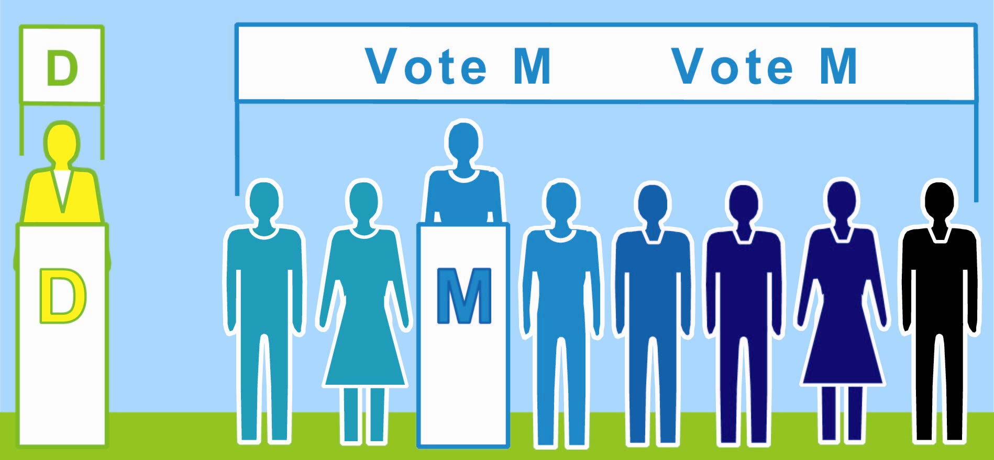  Three Sections Together In One Election  l l l l l l l  8 M  votes; 3 are wasted on a surplus.  Section One's Election  1 D vote  wasted on a loser  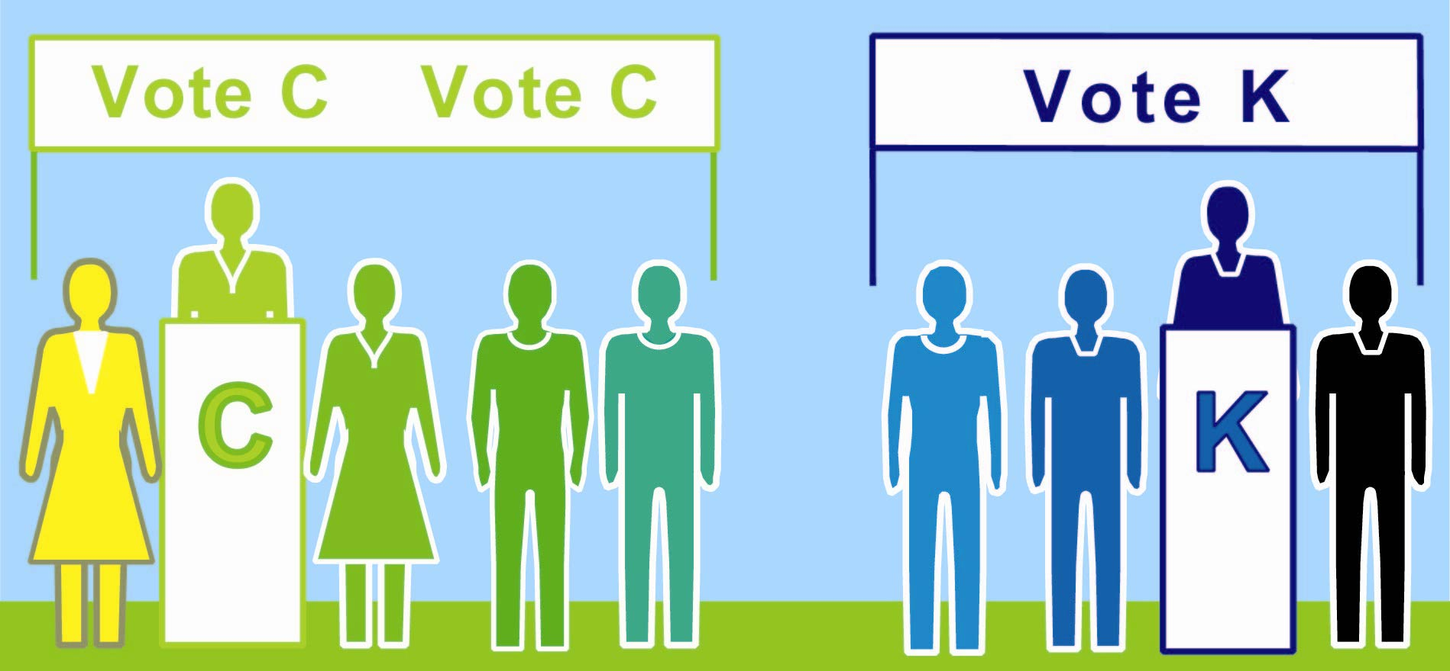  = = = = = =  4 K  votes wasted on a loser.  Section  Two's Election  5 C votes elect a rep.  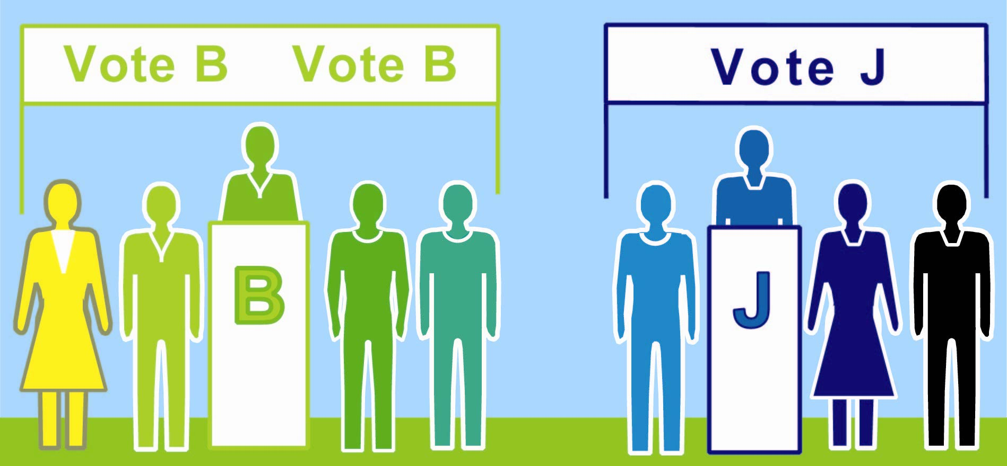  lll ... l ... ... ... ... ...  4 J  votes wasted  on a  loser.  Section  Three's Election  5 B votes elect a rep.   An 11-voter minority gets 2 reps; that’s majority power.  If spread out, 3 or 4 in each section, they’d get no rep.  The plurality rule often wastes votes so it’s easy to rig  by changing the borders of election districts. page 32  How many votes were wasted? 12 20 | One Fair Representation Election  A better idea: “Keep the class whole. Change the votes  needed from 1/2 of a section to 1/4 of the class plus 1.  To win here, you need to get the ballots of 7 voters.  A voter may rank a first choice and a backup choice.  If his first choice loses, his vote counts for his backup.”  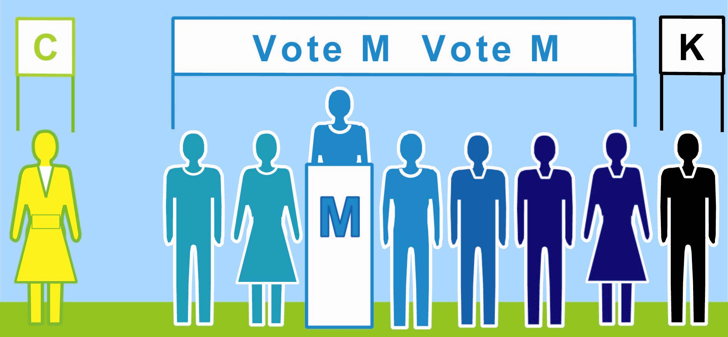  l l l l l l l  7 voters rank M > K > J.  M wins. Any surplus helps each voter’s  backup.  l = = = = = l =  4 votes  help  elect K.  6 rank C > B.  5 votes  help  elect C.  lll ... l ... ... ... ... ...  C  J loses;  these backup choices help elect K.  B loses;  these backup choices help  elect C.  K  Final 11 C (4 surplus) 7 M 9 K (2 surplus)   Now the minority gets 1 rep and the majority gets 2.  Their mandate is more fair, accurate and strong.  The voters on the left chose rep C.  How many votes were wasted? just 6 21

