Ranked Choice Ballots  A small tally board can serve 30 voters. It’s easier to mark paper ballots or webpages and tally by computer. Some groups need the secure paper ballots or printouts used by “risk-limiting audits” to catch frauds or errors.³  ☒ Yes-or-no ballots badly oversimplify most issues. They often highlight only two factions: “us versus them.” They tend to polarize and harden conflicts.  O Ranked choice ballots reduce those problems. They let you rank your 1st choice, 2nd choice, 3rd etc. Ranks can reveal a great variety of opinions. Surveys find most voters like the power to rank candidates.⁴  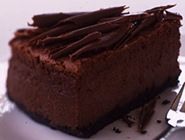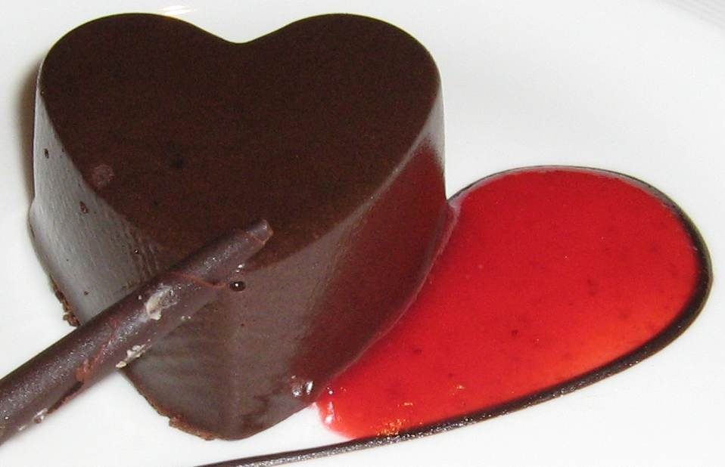  Party Menu Fill only one “O” on each line.  Best Ranks Worst  Treats Ballot #2 1st 2nd 3rd 4th 5th 6th  1 Fruit & Nut Platter  O O O O O  6 Chocolate Brownies O O O O O O  3 Choc. Fudge FroYos O O O O O O  1 “ Cheesecake Slices O O O O O O  3 Choc. Mousse Hearts O O O O O O  6 Choc. Chip Muffins O O O O O O  . 43 |  | Ranked Choice Ballots  A small tally board can serve 30 voters. It’s easier to mark paper ballots or webpages and tally by computer. Some groups need the secure paper ballots or printouts used by “risk-limiting audits” to catch frauds or errors.³  ☒ Yes-or-no ballots badly oversimplify most issues. They often highlight only two factions: “us versus them.” They tend to polarize and harden conflicts.  O Ranked choice ballots reduce those problems. They let you rank your 1st choice, 2nd choice, 3rd etc. Ranks can reveal a great variety of opinions. Surveys find most voters like the power to rank candidates.⁴  Party Ballot #2 Fill only one “O” on each line.  Best Ranks Worst  Smorgasbord 1st 2nd 3rd 4th 5th 6th  1 Fruit & Nut Platter  O O O O O  2 Caviar Side dishes O O O O O O  6 Vegetable Sides O O O O O O  1 Conch Platter O O O O O O  1 Maine Lobster O O O O O O  1 Whole Salmon O O O O O O  1 Oyster Platter O O O O O O  2 Crab Platters O O O O O O  3 Scrod Platters O O O O O O  . 45
THE COLLECTIVE CAFÉ *  Wish Snack Cost Value  Ranks Grades  Salty Snacks  ___ Corn Chips 9 oz & Salsa 16 oz 5.00 ___  ___ Potato chips 11 oz & Dip 16 oz 5.00 ___  ___ Pretzels 16 oz 2.50 ___  ___ Triskets 12oz & Pesto 8 oz 7.50 ___  Chocolate Decadence  ___ Pepperidge Farm Chesapeake dark+pecans 7 oz 2.50 ___  ___ Pepperidge Farm Double Chocolate dark 8 oz 2.50 ___  ___ Giant Oatmeal Raison 10 oz 1.00 ___  ___ Pepperidge Farm Oatmeal Cranberry 8 oz 2.50 ___  ___ P.F. Nantucket crisp dark 7 oz 2.50 ___  ___ P.F. Nantucket soft dark 8 oz 2.50 ___  ___ Toll House nuts home made 16 oz 6.00 ___  Healthy Treats  ___ Dried Apricots organic, no sulfides 16 oz 4.50 ___  ___ Pita Bread & Humus 16 oz 7.50 ___  ___ Nut Mix 16 oz 3.00 ___  * No, we do not have a collective stomach. Food is one of the most personal and private goods, so it does not exemplify a "public good" for social choice. But snacks do make our workshop more fun.  Giving more chips to an item does not entitle you to a larger share of it because this is public money used to buy public goods. | :|  . | Workshop Finale Notes  Our ballots from page 45 let us compare some rules. Which 1 wins by plurality? Hints: 5 seafoods vs. 1 nut, and the first name on a ballot gets a 2% to 9% boost.⁵  Eat the winners! while you plan to take a poll for the central majority or fair shares in a group you know. What qualities do you want in this poll? See page 34.  Many groups offer apps to tally your votes.  https://AccurateDemocracy.com/z_tools.htm  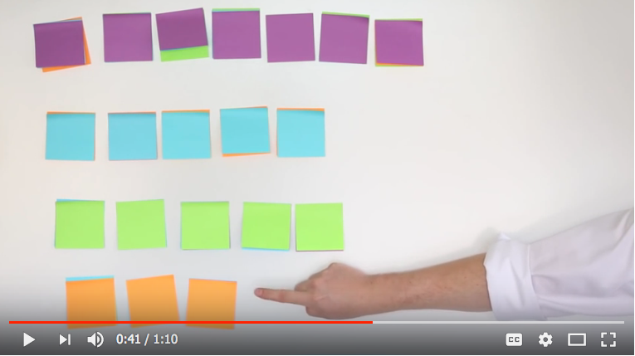  It’s easy to host a workshop in a class or a club.⁶ In an hour, 20 voters can review plurality, try IRV, then  try FSV with treats or STV with colors as shown above.⁷  Hands-on games and shared treats made memories of how each tool works. Next, realistic simulations and national statistics will reveal each tool’s effects. The political effects on pages 54-57 and institutional or societal effects on pages 58-61 are very important.  47
Ranked Choice Ballots  A small tally board can serve 30 voters. It’s easier to mark paper ballots or webpages and tally by computer. Some groups need the secure paper ballots or printouts used by “risk-limiting audits” to catch frauds or errors.³  ☒ Yes-or-no ballots badly oversimplify most issues. They often highlight only two factions: “us versus them.” They tend to polarize and harden conflicts.  O Ranked choice ballots reduce those problems. They let you rank your 1st choice, 2nd choice, 3rd etc. Ranks can reveal a great variety of opinions. Surveys find most voters like the power to rank candidates.⁴  Ranks Project Cost  Salty Snacks  ___ Corn Chips 9 oz & Salsa 16 oz 5.00 ___  ___ Pretzels 16 oz 2.50 ___  ___ Triskets 12oz & Pesto 8 oz 7.50 ___  Chocolate Decadence  ___ Pepperidge Farm Nantucket soft dark 8 oz 2.50 ___  ___ P.F. Nantucket crisp dark 7 oz 2.50 ___  ___ P.F. Chesapeake dark+pecans 7 oz 2.50 ___  ___ Toll House nuts home made 16 oz 6.00 ___  Healthy Treats  ___ Pita Bread & Humus 16 oz 7.50 ___  ___ Nut Mix 16 oz 3.00 ___  48 |  | Ranked Choice Ballots  A small tally board can serve 30 voters. It’s easier to mark paper ballots or webpages and tally by computer. Some groups need the secure paper ballots or printouts used by “risk-limiting audits” to catch frauds or errors.³  ☒ Yes-or-no ballots badly oversimplify most issues. They often highlight only two factions: “us versus them.” They tend to polarize and harden conflicts.  O Ranked choice ballots reduce those problems. They let you rank your 1st choice, 2nd choice, 3rd etc. Ranks can reveal a great variety of opinions. Surveys find most voters like the power to rank candidates.⁴  Party Ballot #2 Fill only one “O” on each line.  Cost Rank Treat  Salty Snacks  5.00 3 Corn Chips 9 oz & Salsa 16 oz  2.50 3 Pretzels 16 oz  7.50 3 Triskets 12oz & Pesto 8 oz  Chocolate Decadence  2.50 3 Pepperidge Farm Nantucket soft dark 8 oz  2.50 3 P.F. Nantucket crisp dark chocolate 7 oz  2.50 3 P.F. Chesapeake dark chocolate+pecans 7 oz  6.00 3 Toll House chips with nuts, home made 16 oz  Healthy Treats  7.50 3 Pita Bread & Humus 16 oz••  3.00 3 Nut Mix 16 oz  45
Ranked Choice Ballots  A small tally board can serve 30 voters. It’s easier to mark paper ballots or webpages and tally by computer. Some groups need the secure paper ballots or printouts used by “risk-limiting audits” to catch frauds or errors.³  ☒ Yes-or-no ballots badly oversimplify most issues. They often highlight only two factions: “us versus them.” They tend to polarize and harden conflicts.  O Ranked choice ballots reduce those problems. They let you rank your 1st choice, 2nd choice, 3rd etc. Ranks can reveal a great variety of opinions. Surveys find most voters like the power to rank candidates.⁴  Participatory Budgeting, Ballot #2  Rank Project Cost  ___ Playground Lighting, fencing, signs $500,000  ___ Bike repair stations $12,000  ___ Outdoor Fitness Equipment $100,000  ___ Park garden improvements $100,000  ___ Tree Planting $100,000  ___ Dog run fencing, signs $100,000  ___ Street Art Trail $500,000  ___ Safer Crosswalks for Busy Roads $500,000  ___ Sidewalk repairs along High St $500,000  ___ Security Lighting along High St $500,000  ___ Security Cameras along High St $500,000  45 |  | Ranked Choice Ballots  A small tally board can serve 30 voters. It’s easier to mark paper ballots or webpages and tally by computer. Some groups need the secure paper ballots or printouts used by “risk-limiting audits” to catch frauds or errors.³  ☒ Yes-or-no ballots badly oversimplify most issues. They often highlight only two factions: “us versus them.” They tend to polarize and harden conflicts.  O Ranked choice ballots reduce those problems. They let you rank your 1st choice, 2nd choice, 3rd etc. Ranks can reveal a great variety of opinions. Surveys find most voters like the power to rank candidates.⁴  Party Ballot #2 Fill only one “O” on each line.  Cost Rank Treat  Salty Snacks  5.00 3 Corn Chips 9 oz & Salsa 16 oz  2.50 3 Pretzels 16 oz  7.50 3 Triskets 12oz & Pesto 8 oz  Chocolate Decadence  2.50 3 Pepperidge Farm Nantucket soft dark 8 oz  2.50 3 P.F. Nantucket crisp dark chocolate 7 oz  2.50 3 P.F. Chesapeake dark chocolate+pecans 7 oz  6.00 3 Toll House chips with nuts, home made 16 oz  Healthy Treats  7.50 3 Pita Bread & Humus 16 oz••  3.00 3 Nut Mix 16 oz  . 45
Ranked Choice Ballots  A small tally board can serve 30 voters. It’s easier to mark paper ballots or webpages and tally by computer. Some groups need the secure paper ballots or printouts used by “risk-limiting audits” to catch frauds or errors.³  ☒ Yes-or-no ballots badly oversimplify most issues. They often highlight only two factions: “us versus them.” They tend to polarize and harden conflicts.  O Ranked choice ballots reduce those problems. They let you rank your 1st choice, 2nd choice, 3rd etc. Ranks can reveal a great variety of opinions. Surveys find most voters like the power to rank candidates.⁴  Participatory Budgeting, Ballot #2  Rank Project Cost  2 Market St just 20 New Trees $100,000  1 “ all 40 New Trees $180,000  3 “ Security Lighting $200,000  9 “ Security Cameras $500,000  1 Park garden improvements $100,000  1 Tree Planting $100,000  1 Dog run fencing, signs $100,000  1 Outdoor Fitness Equipment $100,000  1 Street Art Trail $500,000  1 Safer Crosswalks for Busy Roads $500,000  1 Sidewalk repairs along High St $500,000  45 |  | Ranked Choice Ballots  A small tally board can serve 30 voters. It’s easier to mark paper ballots or webpages and tally by computer. Some groups need the secure paper ballots or printouts used by “risk-limiting audits” to catch frauds or errors.³  ☒ Yes-or-no ballots badly oversimplify most issues. They often highlight only two factions: “us versus them.” They tend to polarize and harden conflicts.  O Ranked choice ballots reduce those problems. They let you rank your 1st choice, 2nd choice, 3rd etc. Ranks can reveal a great variety of opinions. Surveys find most voters like the power to rank candidates.⁴  Party Ballot #2 Fill only one “O” on each line.  Cost Rank Treat  Salty Snacks  5.00 3 Corn Chips 9 oz & Salsa 16 oz  2.50 3 Pretzels 16 oz  7.50 3 Triskets 12oz & Pesto 8 oz  Chocolate Decadence  2.50 3 Pepperidge Farm Nantucket soft dark 8 oz  2.50 3 P.F. Nantucket crisp dark chocolate 7 oz  2.50 3 P.F. Chesapeake dark chocolate+pecans 7 oz  6.00 3 Toll House chips with nuts, home made 16 oz  Healthy Treats  7.50 3 Pita Bread & Humus 16 oz••  3.00 3 Nut Mix 16 oz  . 45

