| | |
Barcode and Post Office Markings  POSTAL  INDICIA  Dear Obies,  During a college reunion, I gave one booklet to  each residence, hoping its ideas would grow in their conversations. Two years later, students petitioned for a referendum and the following year 62% voted for Ranked Choice Voting to elect the Student Senate. That may have been a coincidence, of course,  but I think the booklets probably helped.  The online edition may help the co-ops, senate, SFC, faculty, trustees or town adopt more tools  for Accurate Democracy. — R. Loring  FairVote  8484 Georgia Avenue,  Suite 240,  Silver Spring, MD 20910  $  $  $  Ranked Choice Voting Games  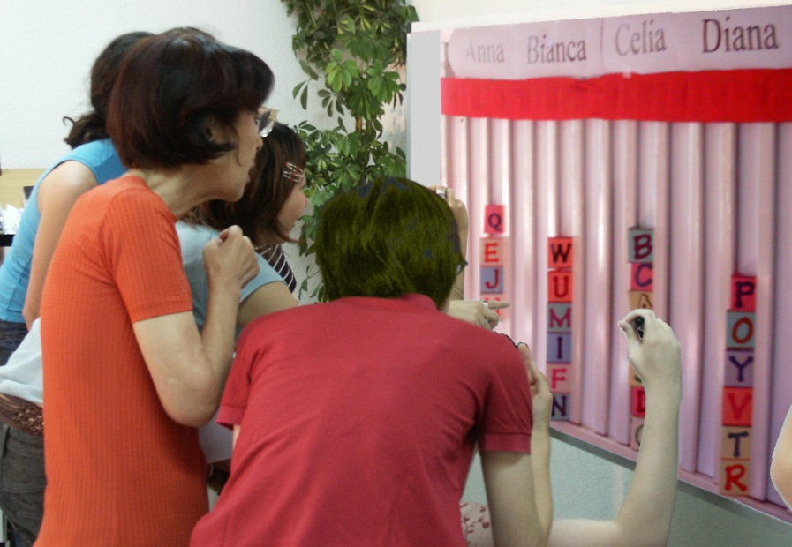  for Schools, Clubs, Towns & More | “ This is the site for learning about democracy.”  — Zoe Weil, author of Most Good, Least Harm,  president of the Institute for Humane Education.  “...a huge contribution to the democracy cause.”  — John M. Richardson Jr., former Chairman of  the National Endowment for Democracy.  “ Congratulations on a brilliant piece of work.”  Robert Fuller, former President of Oberlin College,  author of Somebodies and Nobodies and All Rise.  Tools for democracy impact our levels of liberty, social trust, health and happiness.  The best types of voting are fast, easy and fair.  They help groups from classrooms to countries.  They raise the rewards for consensus builders.  They reduce polarizing fear, anger and gridlock.  One easy tool compares the votes on all the options for a policy. Other tools give out  fair shares of seats or $pending.  $ $ $  $ $ $  $ $ $        Accurate Democracy  is strongly centered  yet inclusive and fair.  1 |  |   Accurate Democracy eBook  Free  Contents  Parts A, B, and C each show the four voting tools  A. Voting Primer tells the stories of the four tools   Tragedies, Eras and Progress of Democracy 4  1. Ranked Choice Voting elects a majority Leader 14  2. Fair Representation elects a balanced Council 16  3. Fair Share Voting sets optional Budgets New 22  4. Condorcet Tally enacts a balanced Policy " 28  Rigged votes, Gerrymanders and Gridlock 32  ★ Social Effects of group decision tools 35  Complementing Consensus 37  How we can try a group-decision tool 38  B. Workshop Games let us be inside the four tallies  C. SimElection™ Maps make tally patterns visible  References, Glossary and Index, About Us 60  1. Ranked Choice Voting, RCV, elects leaders.  Many cities are adopting it from California to Minnesota and Maine, Utah to NYC; plus Duke, Harvard, Princeton, Rice, Stanford, Tufts, MIT, Cal Tech, Carlton, Clark, GW, Reed, Vassar, UCSC, and the Universities of Houston,  Auburn, CA, IA, IL, MA, MN, NC, OK, TX, VA, WA and WY.  2. Multi-winner RCV elects balanced councils  at Cambridge, Carnegie Mellon, Clark, CUNY, Oberlin,  Oxford, UC Cal, UC Davis, UCLA, Vassar and more.  Australian and Irish voters have used RCV for decades.
| More pages in the free eBook. |
1. Ranked Choice Voting can elect a  majority winner from a single election  Voting is easy. Rank your favorite as first choice,  and backup choices: second, third, etc. as you like. Your civic duty to vote is done.  Now your vote counts for your top-rank candidate.  If no candidate gets a majority, the one with fewest  votes loses. So we eliminate that one from the tally.  Your vote stays with your favorite if she advances.  If she has lost then your vote counts for your backup.  This repeats until one candidate gets a majority.  Why Support Ranked Choice Voting, RCV    Backups give you more power and freedom to  express opinions with less risk of wasting a vote.  No hurting your first choice by ranking a backup, that does not count unless your first choice has lost.  No worry about vote splitting in a faction as votes for its loser(s) can count for each supporter's backup.  A majority winner from one election, so no winner  with a weak mandate and no costly runoff election.  High voter turnout also creates a strong mandate.  The turnout for an election runoff often goes down.²  More civility and consensus³ arise as candidates  ask a rival’s fans for their backup votes.⁴  14 www.fairvote.org/get_involved | Summary and Index of Benefits  Ranked Choice Voting has proven to Page*  1, 2, 3, 4. Make voting easy, more effective 14, 57  Give you power to rank a backup choice; so 33, 46  Reduce your risk of wasting your vote; so 12, 16  Vote worry free for your true first choice. 14  Boost mandates as more voters count. 11-17, 57  1, 2. Reduce attack ads that scare, anger, polarize. 14    Weaken gerrymanders and spoilers. 14, 16, 32  2. Give fair shares of reps to the rival groups; so 18  Diverse candidates have real chances to win; so 20  Voters have real choices and effective votes; so 17  Voter turnout is stronger. 61  2. Elect women twice as often as plurality does; so 20  Accurate majorities win, also due to more choices 17  turnout, effective votes, equal votes per rep; so 21  Policies match public opinion better. 21, 60  Even then, old decision tools push policy pendulums 4  ★★ An RCV toolbox can do more ★★  4. Elect a few central reps, the key votes pulling 31  reps from many factions to moderate policies. 8, 54  3. Use Fair Share Voting for projects, savings, etc. 24  Let all voters see each rep’s spending. 27  3, 4. Reduce agenda effects and scams. 27, 30, 33, 36  Streamline group decision-making. 27, 33, 36  34 *AccurateDemocracy.com/AcDem.pdf | ★★ Social Effects ★★  These Are Tools Between People  A group’s decision rules pull its culture toward fair shares or toward winner takes all. They spread power wide and balanced, or narrow and lopsided. Other relations among members may follow their models.  Fair rules make cooperation safer, faster and easier. This favors people and groups who tend to cooperate. It may lead others to cooperate more often.  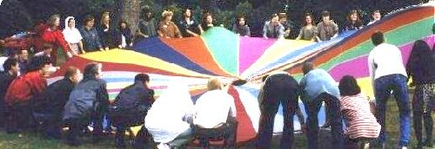  Politics are more principled and peaceful when all the rules help us find fair shares and central majorities. This might reduce political fears within our community; which helps us to be more receptive, creative and free.  So better rules help us build better decisions, plus better relationships. Both can please most people. Fair rules won’t please some who get money or self-esteem from war-like politics. But countries with fair rules tend to rank high in social trust and happiness.¹ Voting is an exemplary tool between people.  © 2023, Robert B. Loring, VotingSite@gmail.com 35

