“This is the site for learning about democracy.”  —Zoe Weil, author of Most Good, Least Harm, president of the Institute for Humane Education.  “... a huge contribution to the democracy cause.”  —John M. Richardson Jr., former Chairman of the National Endowment for Democracy.  “Congratulations on a brilliant piece of work.”  —Robert Fuller, former President of Oberlin College, author of Somebodies and Nobodies, and All Rise.  Touch, See and Hear How  The best voting rules are fast, easy and fair.  They help groups from classrooms to countries.  The results are well centered and widely popular.  They strengthen the votes supporting  $ $  $ $  one chairperson or policy and  1  fair-shares of seats or $pending.  Then Act  Share this illustrated booklet with friends.  Build support in your school, club or town.  Enjoy better relations, politics, and policies,  pages 33, 36 and 57. | ACCURATE DEMOCRACY | Accurate  Democracy  4 Decision Tools  with Pictures & Games

More Endorsements  See many more at fairvote.org/endorsers.htm  “I like your thoughtful application of the best voting techniques to the PB process.” [Participatory Budgeting]  —Tree Bressen, a leading author on group facilitation, Group-Process Pattern Language, groupworksdeck.org  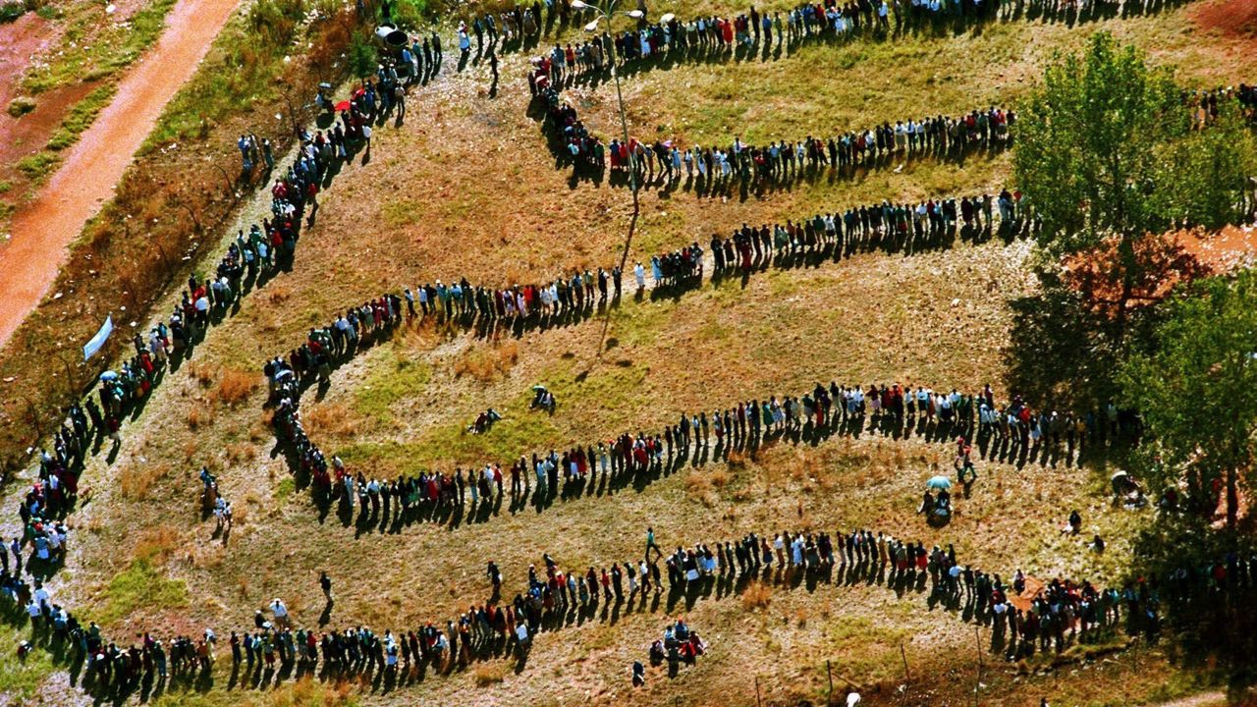  “A very interesting site about voting procedures is: Accurate Democracy. Highly recommended.”  – Prof. Arkadii Slinko, mathematical politics, NZ.  Many groups have given endorsements, editorials, or testimonials for ranked choice voting. Here are a few:  Leagues of Women Voters: Arizona, California, Florida, Massachusetts, Minnesota, North Carolina, Oregon, South Carolina, Vermont, and Washington  Cities and colleges on pages 13 and 40. The Academy Awards (Oscars), Common Cause, Sierra Club, Church of England, Unitarian Universalist Association.  National Newspapers: New York Times Sunday 6/10/18, USA Today, Washington Post, recent regional editorials: Portland Press Herald, Las Cruces Sun News,  Journalists: David Brooks 6/1/2018, Hendrik Hertzberg,  Celebrities: Jennifer Lawrence 6/5/2018, Krist Novoselic, John Cleese,  US Senators: John McCain, Barak Obama, Bernie Sanders,  US Reps: Abner Mikva, John Porter, Jamie Raskin, Keith Ellison, John Anderson,  Republican Party Utah, Green Party US, Libertarian Party,  A great voting turnout in the background |  | About Us  About FairVote  FairVote is a nonpartisan champion of electoral reforms that give voters greater choice, a stronger voice, and a representative democracy that works for all Americans.  FairVote has a proven record since 1992 as a trailblazer that advances and wins electoral reforms at the local, state, and national level through strategic research, communications and collaboration. Today we are the driving force behind advancing ranked choice voting and fair representation in multi-winner legislative districts that will open up our elections to better choices, fairer representation and more civil campaigns.  About My Work VotingSite@gmail.com  In 1990, John R. Chamberlin, and Samuel Merrill III gave me permission to use their sim results (pages 60-61) to advance a Condorcet-IRV rule. Throughout the 1990s I created the PoliticalSim™ and SimElection software. They compared 30 single- and multi-winner rules from around the world and were used in a few universities. (Pages 46-55 show graphics from the simulation games.) By 1998 I had started the Democracy Evolves website. Then I helped FairVote.org as webmaster and librarian. I’ve helped Robert Tupelo-Schneck and Twin Oaks Community test Fair Share Voting for 10 years. This booklet summarizes Accurate Democracy.com.  My work aims for systemic changes (eg, pages 34-36) via better tools between people (eg, pages 33, 23, 25)  Freedom_Day_S_A by Denis Farrel

